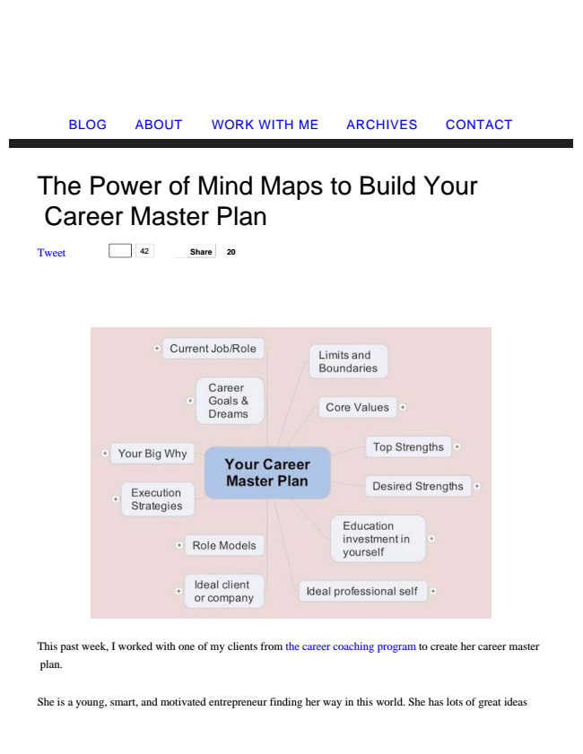

The Power of Mind Maps to Build Your

Career Master Plan

Tweet 42

**Share 20**

BLOG ABOUT WORK WITH ME ARCHIVES CONTACT

This past week, I worked with one of my clients from the career coaching program to create her career master

plan.

She is a young, smart, and motivated entrepreneur finding her way in this world. She has lots of great ideas

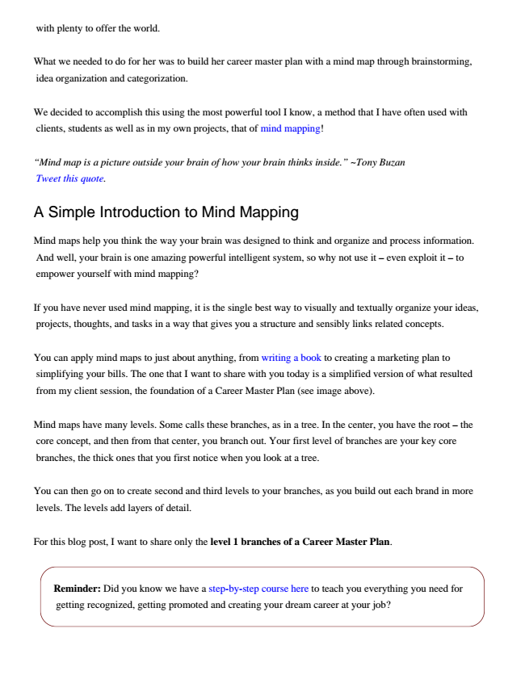

with plenty to offer the world.

What we needed to do for her was to build her career master plan with a mind map through brainstorming,

idea organization and categorization.

We decided to accomplish this using the most powerful tool I know, a method that I have often used with

clients, students as well as in my own projects, that of mind mapping!

*“Mind map is a picture outside your brain of how your brain thinks inside.” ~Tony Buzan*

*Tweet this quote.*

A Simple Introduction to Mind Mapping

Mind maps help you think the way your brain was designed to think and organize and process information.

And well, your brain is one amazing powerful intelligent system, so why not use it – even exploit it – to empower yourself with mind mapping?

If you have never used mind mapping, it is the single best way to visually and textually organize your ideas,

projects, thoughts, and tasks in a way that gives you a structure and sensibly links related concepts.

You can apply mind maps to just about anything, from writing a book to creating a marketing plan to

simplifying your bills. The one that I want to share with you today is a simplified version of what resulted from my client session, the foundation of a Career Master Plan (see image above).

Mind maps have many levels. Some calls these branches, as in a tree. In the center, you have the root – the

core concept, and then from that center, you branch out. Your first level of branches are your key core branches, the thick ones that you first notice when you look at a tree.

You can then go on to create second and third levels to your branches, as you build out each brand in more

levels. The levels add layers of detail.

For this blog post, I want to share only the level 1 branches of a Career Master Plan.

Reminder: Did you know we have a step-by-step course here to teach you everything you need for

getting recognized, getting promoted and creating your dream career at your job?

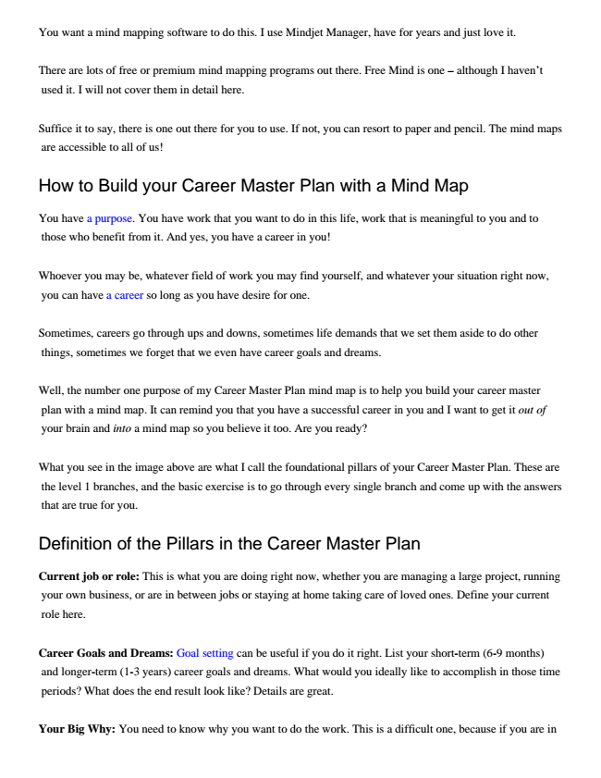

You want a mind mapping software to do this. I use Mindjet Manager, have for years and just love it.

There are lots of free or premium mind mapping programs out there. Free Mind is one – although I haven’t

used it. I will not cover them in detail here.

Suffice it to say, there is one out there for you to use. If not, you can resort to paper and pencil. The mind maps

are accessible to all of us!

How to Build your Career Master Plan with a Mind Map

You have a purpose. You have work that you want to do in this life, work that is meaningful to you and to

those who benefit from it. And yes, you have a career in you!

Whoever you may be, whatever field of work you may find yourself, and whatever your situation right now,

you can have a career so long as you have desire for one.

Sometimes, careers go through ups and downs, sometimes life demands that we set them aside to do other

things, sometimes we forget that we even have career goals and dreams.

Well, the number one purpose of my Career Master Plan mind map is to help you build your career master

plan with a mind map. It can remind you that you have a successful career in you and I want to get it out of your brain and into a mind map so you believe it too. Are you ready?

What you see in the image above are what I call the foundational pillars of your Career Master Plan. These are the level 1 branches, and the basic exercise is to go through every single branch and come up with the answers that are true for you.

Definition of the Pillars in the Career Master Plan

Current job or role: This is what you are doing right now, whether you are managing a large project, running

your own business, or are in between jobs or staying at home taking care of loved ones. Define your current role here.

Career Goals and Dreams: Goal setting can be useful if you do it right. List your short-term (6-9 months)

and longer-term (1-3 years) career goals and dreams. What would you ideally like to accomplish in those time periods? What does the end result look like? Details are great.

Your Big Why: You need to know why you want to do the work. This is a difficult one, because if you are in

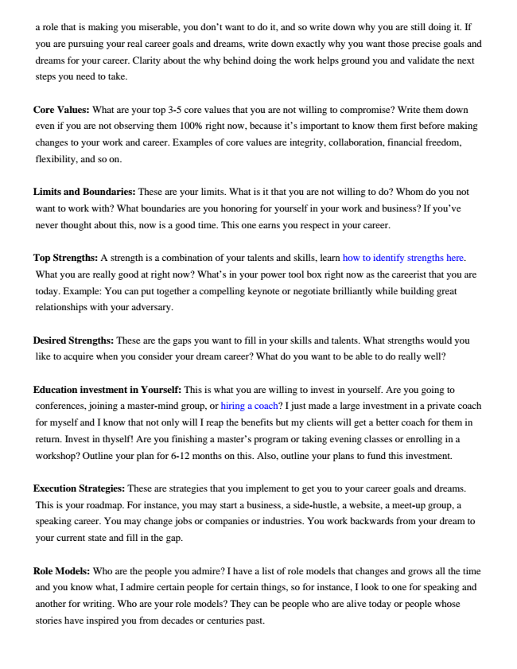

a role that is making you miserable, you don’t want to do it, and so write down why you are still doing it. If you are pursuing your real career goals and dreams, write down exactly why you want those precise goals and dreams for your career. Clarity about the why behind doing the work helps ground you and validate the next steps you need to take.

Core Values: What are your top 3-5 core values that you are not willing to compromise? Write them down

even if you are not observing them 100% right now, because it’s important to know them first before making changes to your work and career. Examples of core values are integrity, collaboration, financial freedom, flexibility, and so on.

Limits and Boundaries: These are your limits. What is it that you are not willing to do? Whom do you not

want to work with? What boundaries are you honoring for yourself in your work and business? If you’ve never thought about this, now is a good time. This one earns you respect in your career.

Top Strengths: A strength is a combination of your talents and skills, learn how to identify strengths here.

What you are really good at right now? What’s in your power tool box right now as the careerist that you are today. Example: You can put together a compelling keynote or negotiate brilliantly while building great relationships with your adversary.

Desired Strengths: These are the gaps you want to fill in your skills and talents. What strengths would you

like to acquire when you consider your dream career? What do you want to be able to do really well?

Education investment in Yourself: This is what you are willing to invest in yourself. Are you going to

conferences, joining a master-mind group, or hiring a coach? I just made a large investment in a private coach for myself and I know that not only will I reap the benefits but my clients will get a better coach for them in return. Invest in thyself! Are you finishing a master’s program or taking evening classes or enrolling in a workshop? Outline your plan for 6-12 months on this. Also, outline your plans to fund this investment.

Execution Strategies: These are strategies that you implement to get you to your career goals and dreams. This is your roadmap. For instance, you may start a business, a side-hustle, a website, a meet-up group, a speaking career. You may change jobs or companies or industries. You work backwards from your dream to your current state and fill in the gap.

Role Models: Who are the people you admire? I have a list of role models that changes and grows all the time and you know what, I admire certain people for certain things, so for instance, I look to one for speaking and another for writing. Who are your role models? They can be people who are alive today or people whose stories have inspired you from decades or centuries past.

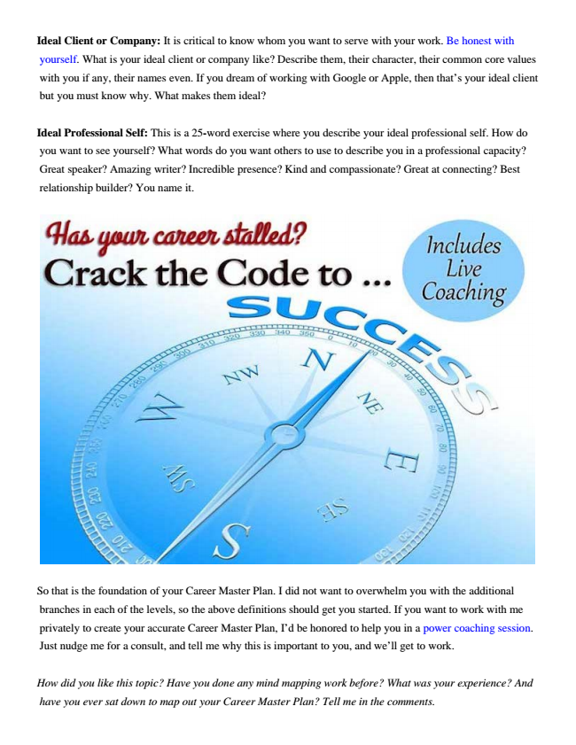

Ideal Client or Company: It is critical to know whom you want to serve with your work. Be honest with

yourself. What is your ideal client or company like? Describe them, their character, their common core values with you if any, their names even. If you dream of working with Google or Apple, then that’s your ideal client but you must know why. What makes them ideal?

Ideal Professional Self: This is a 25-word exercise where you describe your ideal professional self. How do you want to see yourself? What words do you want others to use to describe you in a professional capacity? Great speaker? Amazing writer? Incredible presence? Kind and compassionate? Great at connecting? Best relationship builder? You name it.

So that is the foundation of your Career Master Plan. I did not want to overwhelm you with the additional

branches in each of the levels, so the above definitions should get you started. If you want to work with me privately to create your accurate Career Master Plan, I’d be honored to help you in a power coaching session. Just nudge me for a consult, and tell me why this is important to you, and we’ll get to work.

*How did you like this topic? Have you done any mind mapping work before? What was your experience? And*

*have you ever sat down to map out your Career Master Plan? Tell me in the comments.*



And if you are ready to make things HAPPEN in your career, to get promoted, move up the ladder and stop

spinning your wheels, well, first stop working so hard. And second, start learning the strategies:

**Click Here to Grab FREE Little Known Strategies for Advancing & Getting Promoted at Your Job**







